Hanle Effect Lab

*By: Alex Liechty, Crystal Nelson, Junhua Deng*

*Date: May 10, 2022-May 24, 2022*

## Background & Setup (AL, CN, JD 5/10/2022-5/12/2022)

First, we measured the signal width and amplitude for horizontal transmission and then also for 90 degrees off horizontal. Then, we took several trials of the minimum and maximum current values for the coils (expecting for them to be about -.2 Amps and .2 Amps, respectively).

For the main experiment, we then used the varying magnetic field to find a Doppler-free measurement of the Hanle effect to get the lifetime of Mercury’s first excited state. To do this, we used light from a separate mercury source to excite electrons in our main cell of Mercury with a slowly varying magnetic field propagating through it. The induced Larmor precession then decay created a distribution of decay radiation we measured using our setup (shown below). We perform this experiment both at different angles and with and without the coil used to cancel the magnetic field of the Earth.

The decay radiation’s magnitude varied with field strength, which we modeled in our Python code. (The data were automatically as opposed to manually taken, allowing for extremely high measurement volumes at high precision.) Then, we fit this data using our code to the expected Lorentzian timescape, and found the lifetime we were looking for from the parameters needed.

Here is our setup diagram for this lab with labeled parts and indicated signal paths: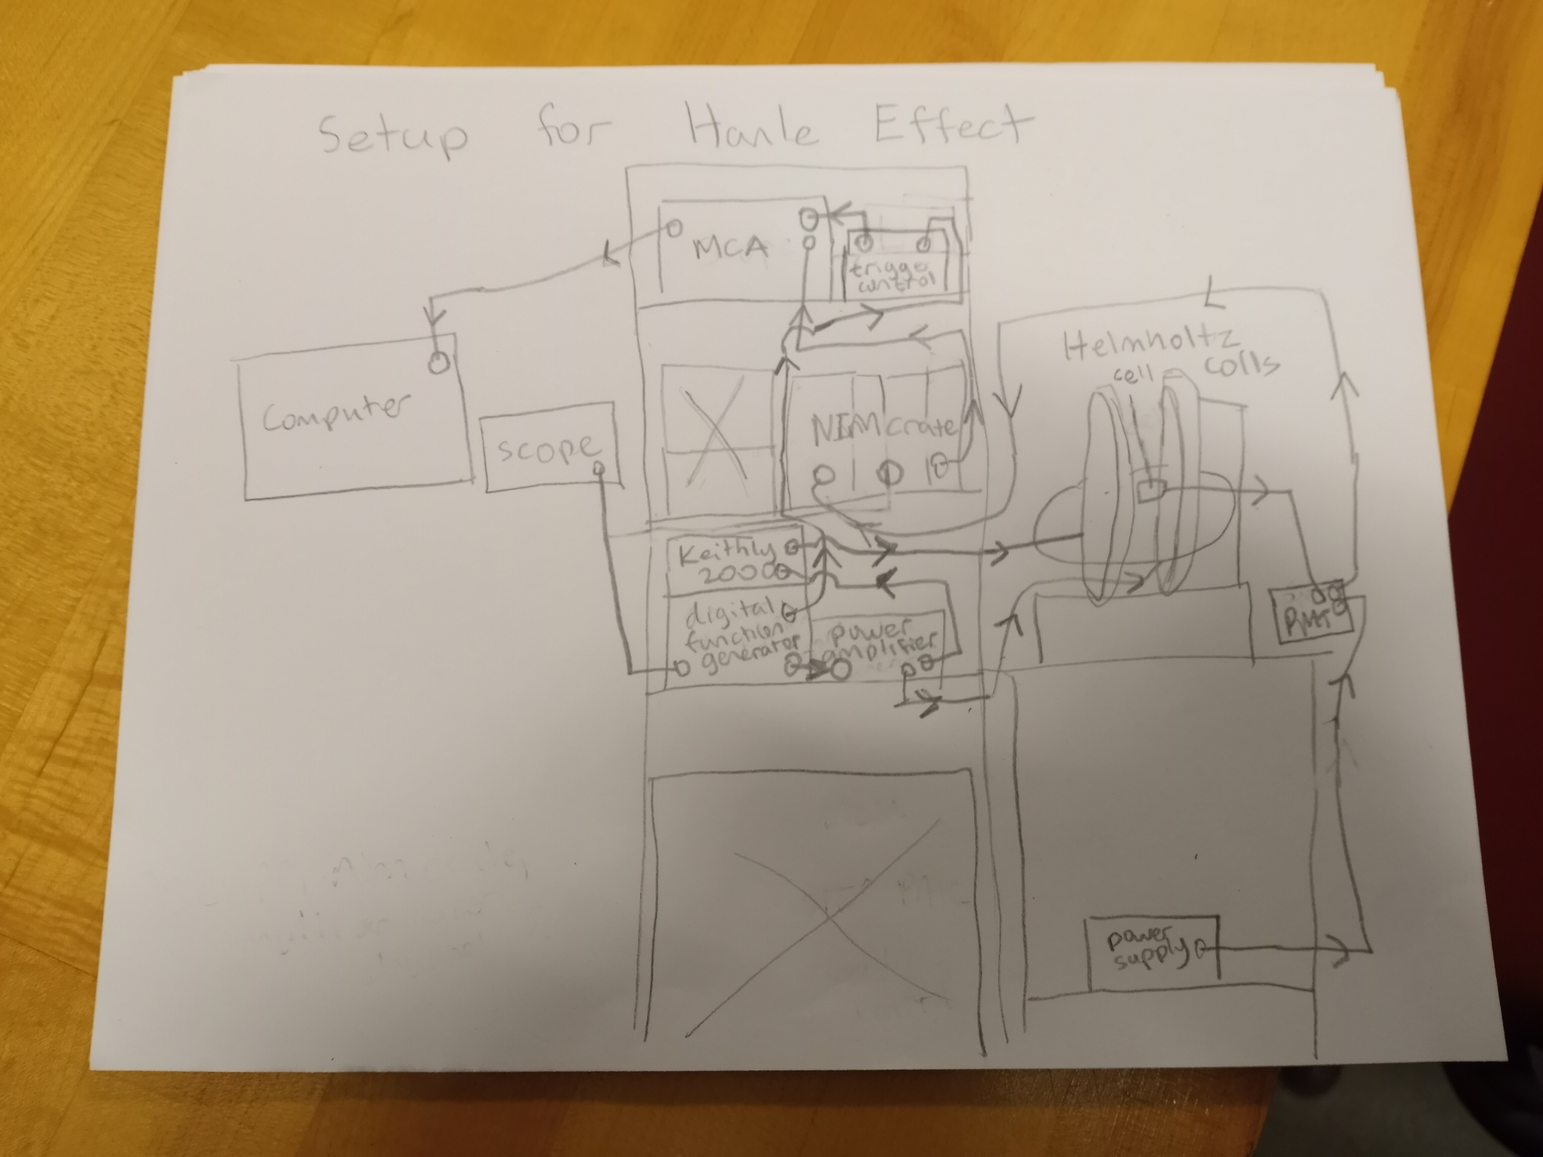

Additionally, here is a photo of our setup: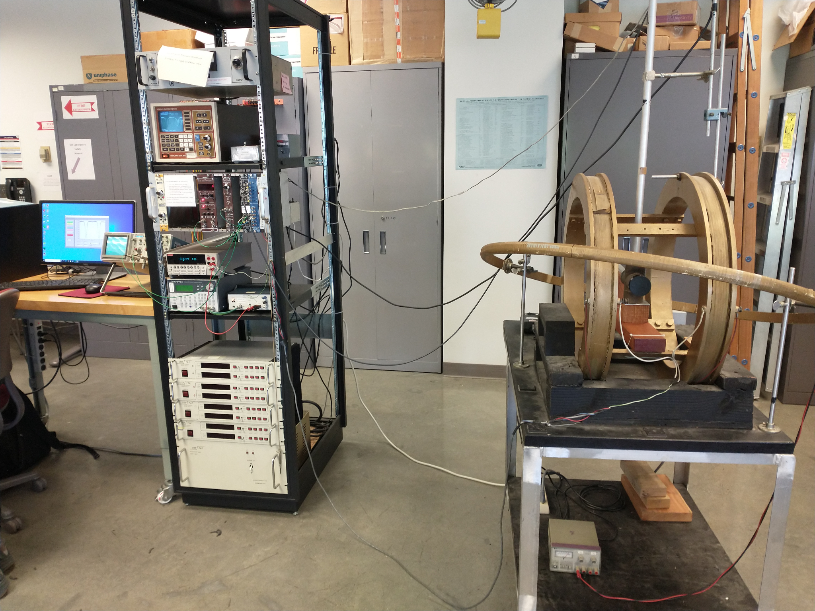

Circuit Diagram: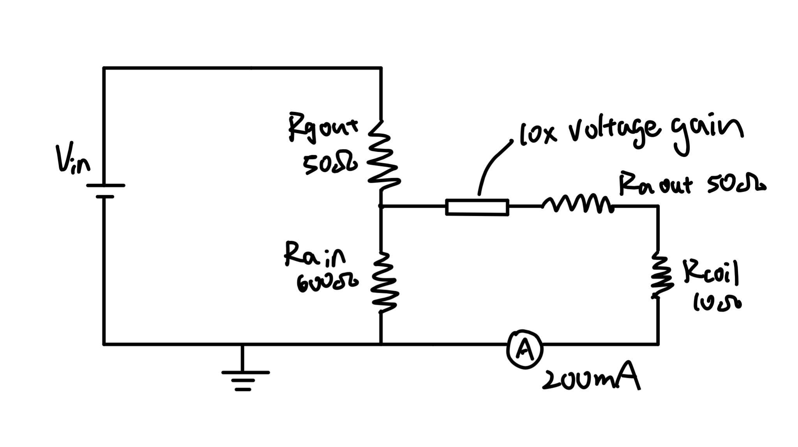

Coil current = 200mA = 0.2A

Voltage out of amplifier = 0.2A*(50Ω+10Ω) = 12V

Voltage into amplifier = 12V/10 = 1.2V

Voltage out of generator(Vin) = 1.2V/[600Ω/(600Ω+50Ω)] = 1.3V

Vpp = 2*1.3V = 2.6V

## Experiment Notes (AL, CN, JD 5/10/2022-5/12/2022)

Settings:

* Keithley 2000: current range 1 Amp, filter OFF, rate MEDIUM
* MCA: ADD, ALL, SWEEPS, T/CH = dwell time 20 ms
* Digital signal generator: triangle wave with 21 second period
* Amplitude of generator output: 2.6 V

Setting up the experiment, we noticed our signal is about 10+/-5 nanoseconds wide for horizontal transmission and has an amplitude of 70mV+/-2mV.

When we rotated 90 degrees before turning the amplifier on, we did not see any notable change in intensity of our waveform.

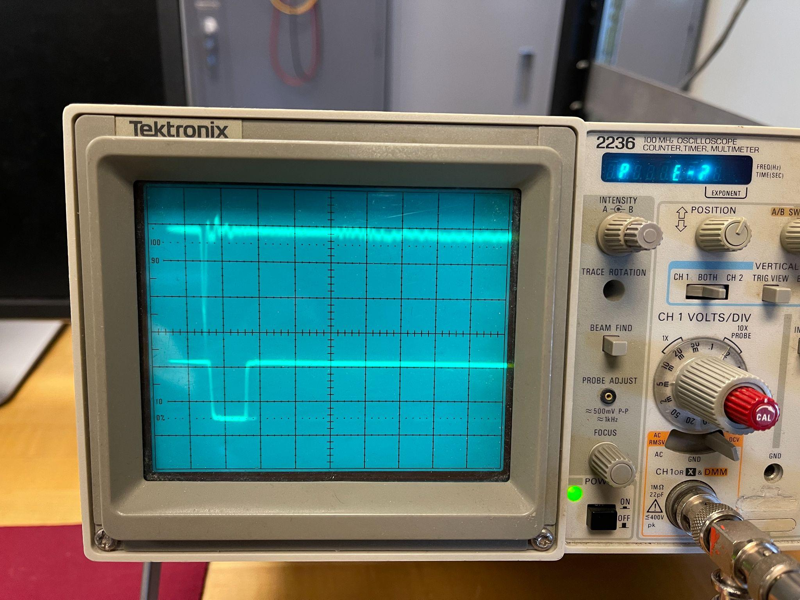

Here is our table of min and max current values for the Helmholtz coils with instrumental uncertainty (random would be calculated from across trials):

|  |  |  |  |  |
| --- | --- | --- | --- | --- |
|  | Trial 1 | Trial 2 | Trial 3 | Trial 4 |
| Minimum Current (Amps) | -.19241 +/- .000005 | -0.19115 +/- .000005 | -0.19201 +/- .000005 | -0.19146 +/- .000005 |
| Maximum Current (Amps) | 0.19968 +/- .000005 | 0.20165 +/- .000005 | 0.20188 +/- .000005 | 0.20127 +/- .000005 |

*We noticed a small but consistent positive bias to the current values, as the absolute values of the maximum current are higher than those of the minimum current values. However, this difference is very slight and thus should not have a significant impact on the final results. Should it be a contributing factor to our results falling outside the accepted range of uncertainty, we will address this more in the data assessment portion of the report.

Here is our initial plot for 0 degree rotation: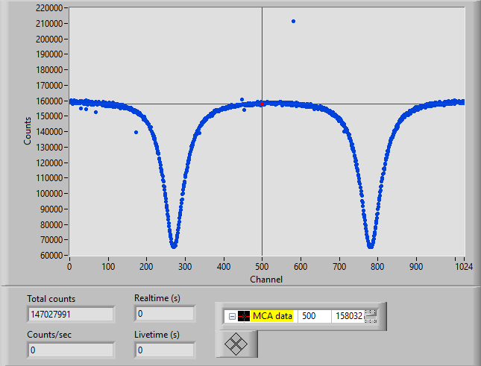

Here is our plot for 0 degree rotation with the bucker off: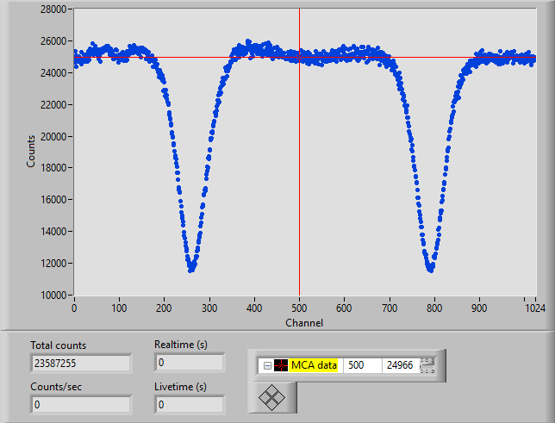

Here is our plot for 0 degree rotation with the bucker on: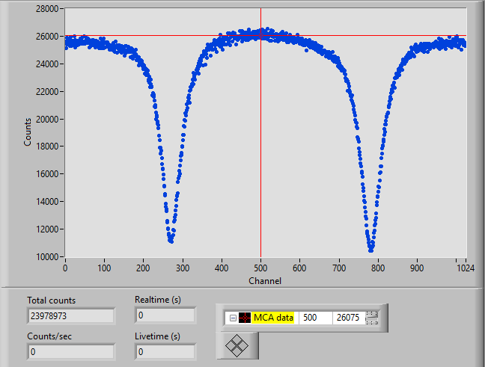

Here is our plot for -90 degree rotation: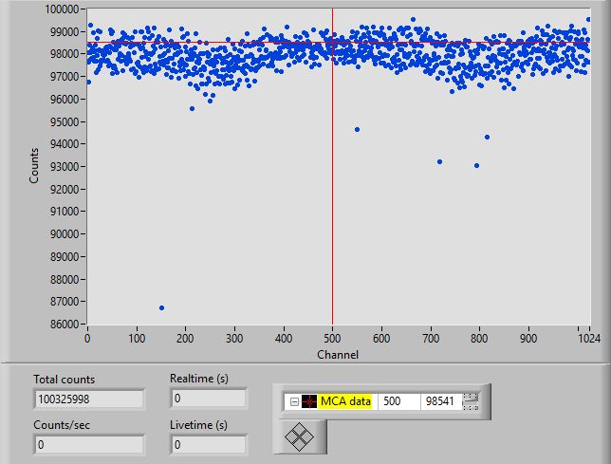

## Data reduction & Preliminary results (AL, CN, JD 5/10/2022-5/12/2022)

As noted earlier, our raw data for the current through the coils had a feature of biasing towards positive current; this was not a feature likely to change our results for the main experiment, though, so we moved forward to collect the Hanle effect data. This was the case because otherwise, the values were as expected for the net range in Amps, and the ~5% positive bias was not something which would significantly alter the time values we use for the effect calculations.

Our raw data graphs appeared to come out as expected, with the exception of a few outlier points in the data (which had little effect due to the extremely high volume of data we collected). We had to redo the -90 degree graph, but this was due to formatting only. (There was a setting that shifted the graph too far upwards to be readable.) All other trials produced data that looked as we wanted it to prior to putting it into the Python notebook we created.

We took 4 data sets to explore this experiment. For the first dataset we ran about 50 sweeps with vertical polarization and the bucking coil on which gave initial results:

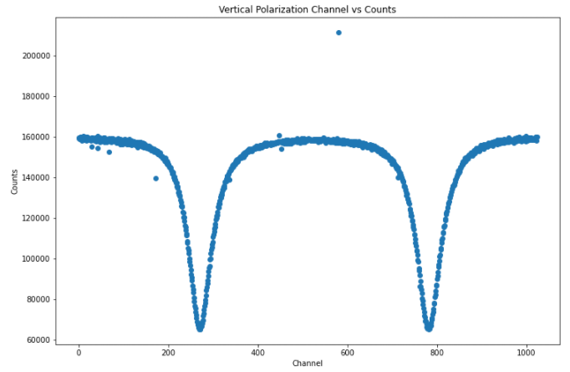

Then to explore the effect of the polarization of light, a 30 sweep dataset was taken with horizontal polarization which gave the data:

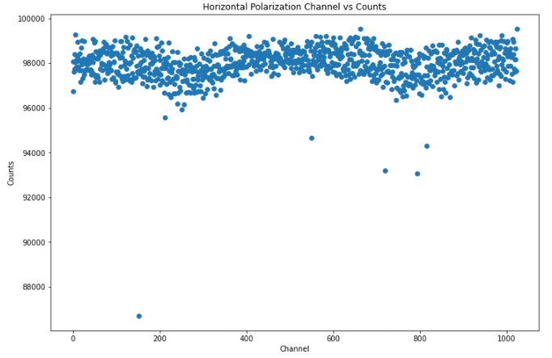

Then, to explore the effect of the Earth’s magnetic field we collected two 20 sweep datasets, one with the bucking coil on, and one with the bucking coil off:

With the bucking coil on:

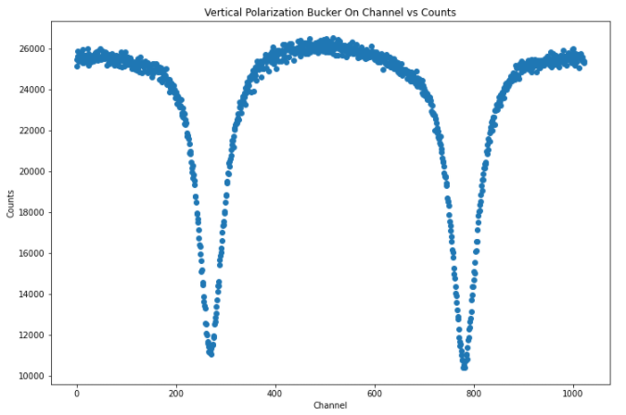

With the bucking coil off:

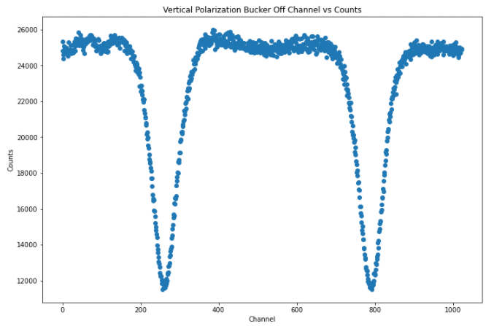

The raw data we collected follows what we expected. For the vertical polarization datasets, there are two distinct negative peaks as expected and for the horizontal polarization, the data is spread out and while there are two shallow peaks, they are not distinct.

It is difficult to tell the difference in the datasets with and without the bucking coil before data analysis, but both datasets gave two negative peaks as expected when using the vertically polarized light.

In order to prepare our data for analysis, we had to invert the data, and then vertically offset the data in order to use the lmfit Python package to fit the peaks to a Lorentzian. This adjustment to our data has no effect on our results because our results are dependent on the half width at half maximum of the peaks and the inversion and vertical offset do not affect the width of the peaks. The vertical offset was determined by taking the average counts of the first 100 channels, because in a Lorentzian these points should be close to zero.

## Final Analysis (AL, CN, JD 5/12/2022-5/24/2022)

There are noticeable outliers in our data, but since there were 1024 channels of data collected, these outliers had a negligible effect on our models.

For the 50 sweep vertical polarization our model gave:

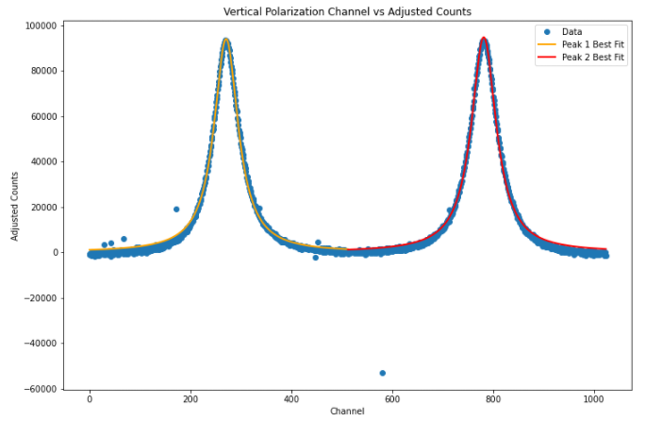

The HWHM of peak 1 is 29.1 +/- 0.2 channels

The HWHM of peak 2 is 30.1 +/- 0.2 channels

Using the half width at half maximum from this fit, we found the deltaB1/2 using:

* the half width at half maximum of the peaks
* the dwell time per channel = 0.02s
* the period of the function generator = 21s
* the maximum and minimum values of the current 0.20112A/-0.19176A
* the conversion of Helmholtz current to magnetic field strength (14.3 Gauss/Amp)

Then, we used this equation to find the mean lifetime:

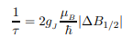

Since we are observing the 63P1 state lifetime in Mercury, we know that S = ½, L = 1, and J = 3/2 which gives gJ = 3/2.

To convert the half width at half maximum to magnetic field, we first multiplied the half width at half maximum by the channel dwell time to get the half width of half maximum in time.

In order to convert from time to amps, we used the fact that we used a triangle wave so the conversion from time to amps is given by the slope of the current:

Δt = 21s/2 = 10.5s

ΔI = 0.20112A - (-0.19176A) = 0.3928775 +/- 4 * 10-6

ΔI / Δt = 0.0374169 +/- 3 * 10-7

Finally, amps were converted to gauss by using the given conversion of 14.3 gauss / amp.

Plugging in the HWHM in gauss into the given equation, we found the lifetime of the 63P1/2 state to be:

Peak 1 Lifetime: (1.215 +/- 0.006) * 10-7 s

Peak 2 Lifetime: (1.178 +/- 0.006) * 10-7 s

This agrees with the results given in the experiment instruction where various literature find a lifetime of the order of 1 * 10-7 s for this state.

Using the same methods, the fit and the values found for the horizontal polarization:

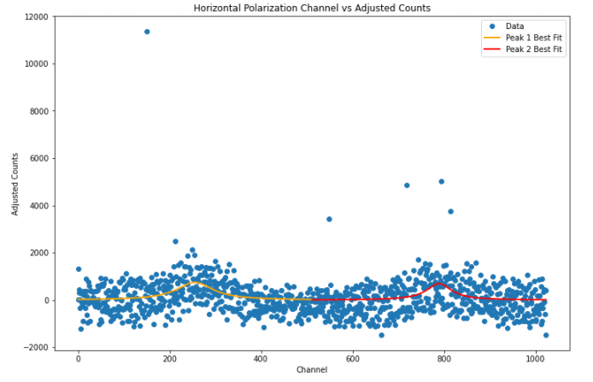

Peak 1 Lifetime: (7 +/-2) * 10-8 s

Peak 2 Lifetime: (1.1 +/- 0.4) * 10-7 s

As expected, the uncertainties are much larger, but for how scattered the data is, the lifetimes are relatively close to the expected values.

For the bucker on and bucker off experiments:

Bucker on:

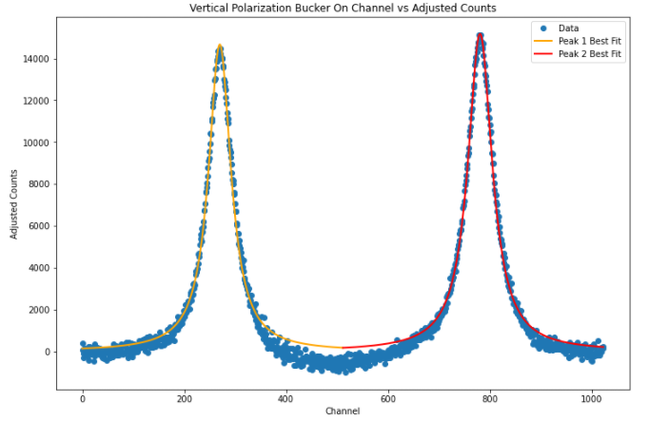

Bucker on Peak 1 lifetime: (1.33 +/- 0.01) * 10-7 s

Bucker on Peak 2 lifetime: (1.21 +/- 0.01) * 10-7 s

Bucker off:

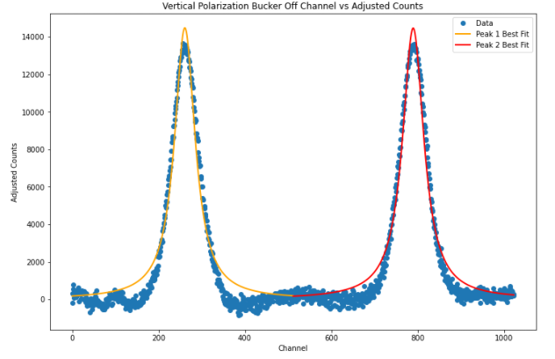

Bucker off Peak 1 lifetime: (1.22 +/- 0.02) * 10-7 s

Bucker off Peak 2 lifetime: (1.18 +/- 0.02) * 10-7 s

Interestingly, the bucker off data provided values that are closer to the literature, but this is primarily due to the fact that these runs were much shorter, only 20 sweeps. The effect of the Earth’s magnetic field can still be observed in this data in the uncertainties; the bucker off data has larger uncertainties.

Also when looking at the HWHM values for bucker on and bucker off datasets:

Bucker on Peak 1 HWHM: (2.85 +/- 0.03) * 10-5 T

Bucker on Peak 2 HWHM: (3.10 +/- 0.03) * 10-5 T

Bucker on Peak 1 HWHM: (3.10 +/- 0.05) * 10-5 T

Bucker on Peak 2 HWHM: (3.21 +/- 0.05) * 10-5 T

The HWHM and uncertainties are larger for the bucker off data which is expected when failing to compensate for the Earth’s magnetic field.

## Assessment and Discussion (CN, AL, JD 5/17/2022-5/24/2022)

Compared to the known values, the data was qualitatively as expected, the experiment instructions provided the following table of measured lifetimes for the 3P1 state for Mercury:

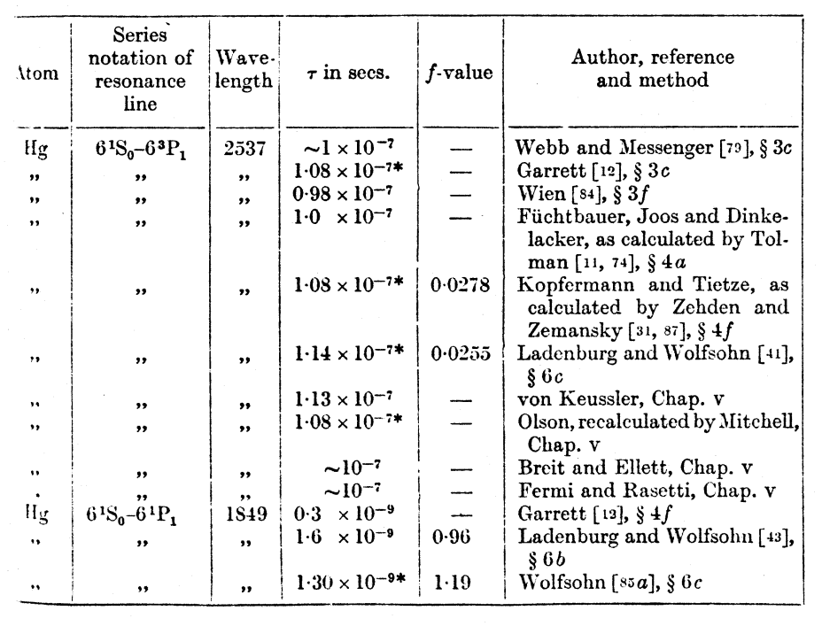

The values we got with our 50 sweep data collection are very close to these values, but are not within our uncertainty of the largest lifetime measured in the table above. The largest lifetime measured in the table above is 1.14 * 10-7 s while our values were (1.215 +/- 0.006) * 10-7 s and (1.178 +/- 0.006) * 10-7 s for peak 1 and 2 respectively. We determined that this slight discrepancy in our measurements either arose from the models being affected by outliers, or the magnetic coils aging which means that the 14.3 Gauss / amp is no longer accurate.

We also had the interesting result that our 20 sweep data run with the bucking coil off was closer to expected values than the 20 sweep data run with the bucker on. This is not expected, but can be explained by the size of the data sets being relatively small. The important feature to notice between these two runs is that the uncertainty in the models for the run without the bucking coil are larger than that of the run with the bucking coil on which suggests that more sweeps would result in more accurate measurements with the bucking coil on.